**VPIP** (VP) **PFR** (Preflop2) 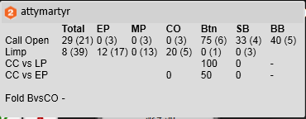 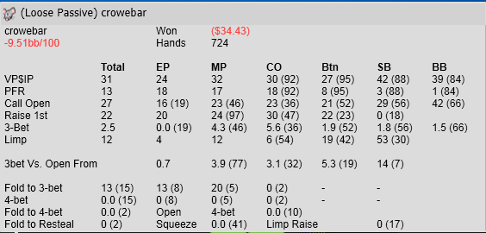

**Total Steal** (STL)  **Limp-Call** (limp)

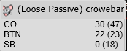 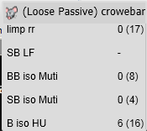

**Skip Flop CBet and Check-Fold OOP** (Cfold)

